PRN – 260245920034

- Display the Employee Name, Job, and Start Date of Employees hired from February 1981 to May 1981.
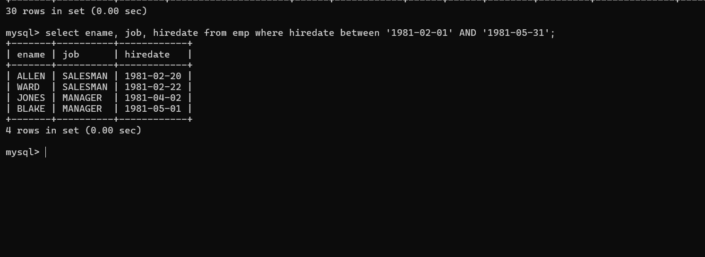
mysql> select ename, job, hiredate from emp where hiredate between '1981-02-01' AND '1981-05-31';

- Display the Name and Hiredate of every Employee who was hired in 1982.
mysql> select ename, hiredate from emp where year(hiredate) = 1982;
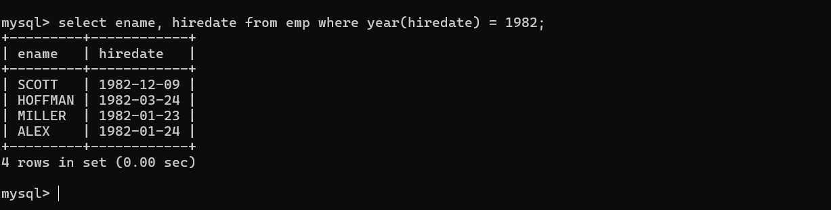
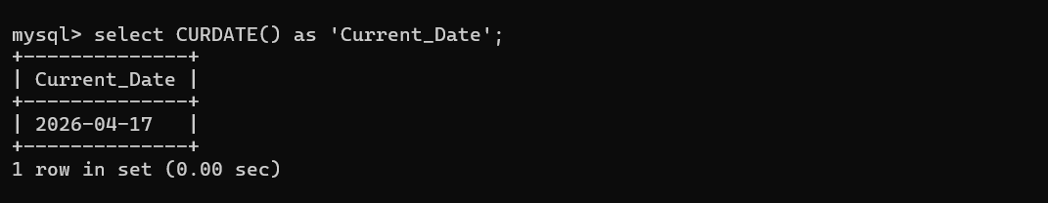
- Write a query to display the current date. Label the column as Current Date.
mysql> select CURDATE() as 'Current_Date';

- Display the Employee’s Name, Hiredate, Salary and Review Date, which is first Monday after six months of service.
SELECT ename,
hiredate,
sal AS Salary,
DATE_ADD(
DATE_ADD(hiredate, INTERVAL 6 MONTH),
INTERVAL ( (7 - WEEKDAY(DATE_ADD(hiredate, INTERVAL 6 MONTH))) % 7 ) DAY
) AS Review_Date
FROM emp;
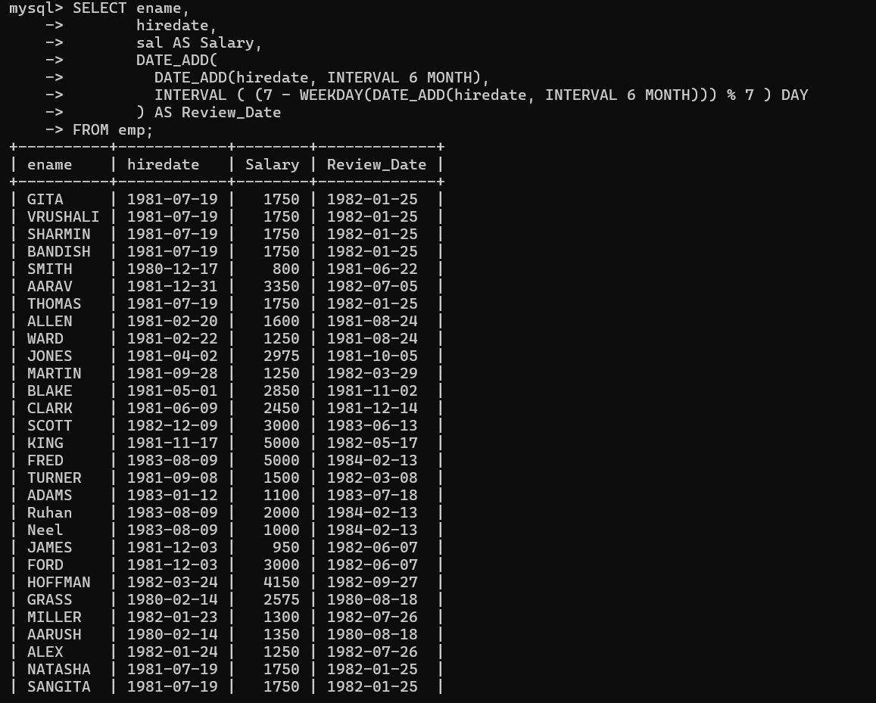

- Modify the query to display the dates as “Sunday, the Seventh of September, 1981”.
SELECT ename,
hiredate,
sal AS Salary,
DATE_FORMAT(
DATE_ADD(
DATE_ADD(hiredate, INTERVAL 6 MONTH),
INTERVAL ( (7 - WEEKDAY(DATE_ADD(hiredate, INTERVAL 6 MONTH))) % 7 ) DAY
),
'%W, the %D of %M, %Y'
) AS Review_Date
FROM emp;
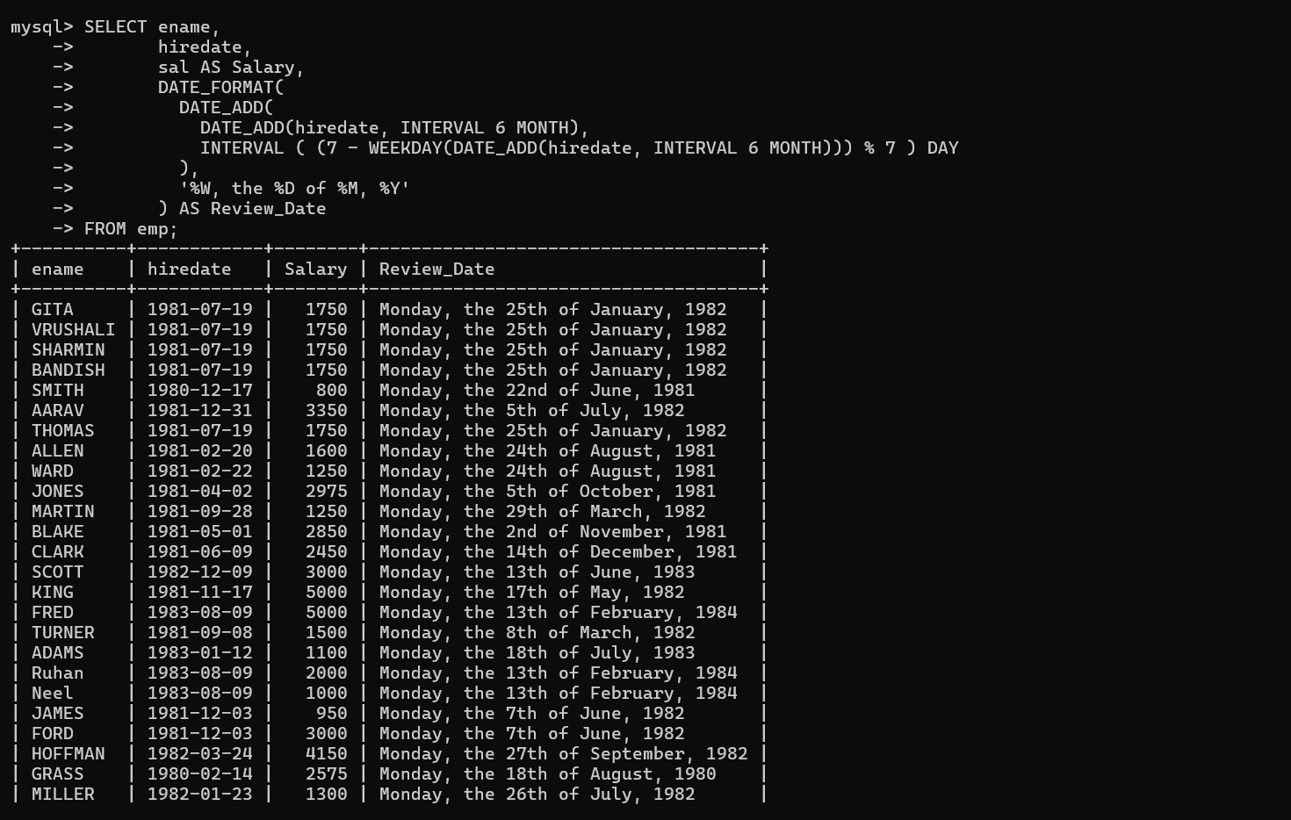

- Create a query to display the name and salary for all Employees. Format the salary to be 15 characters long by adding ‘$’.

SELECT ename,
LPAD(CONCAT('$', sal), 15, ' ') AS Formatted_Salary
FROM emp;
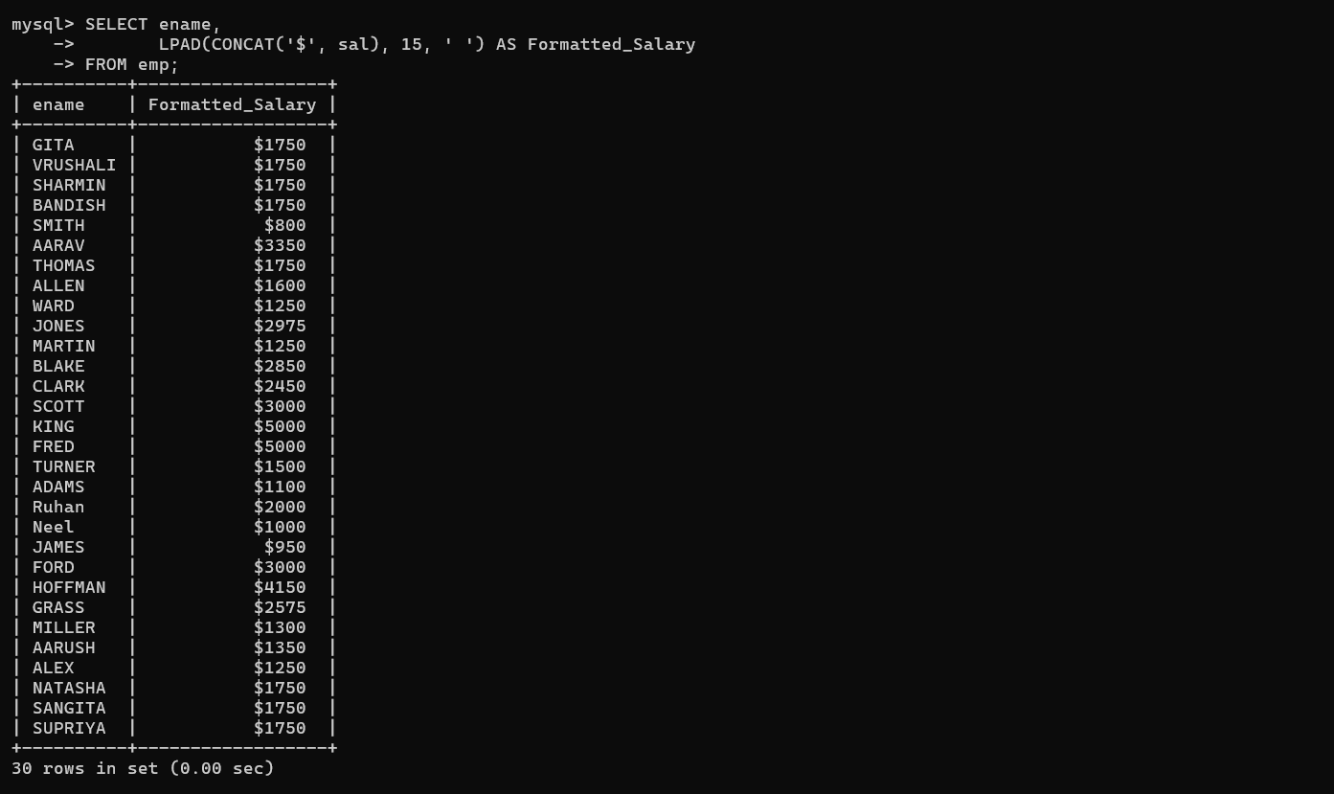
- Display the Name, Hiredate and day of the week on which the employees started. Order the results by the Day of the week starting with Monday.

SELECT ename,
hiredate,
DAYNAME(hiredate) AS Start_Day
FROM emp
ORDER BY WEEKDAY(hiredate);
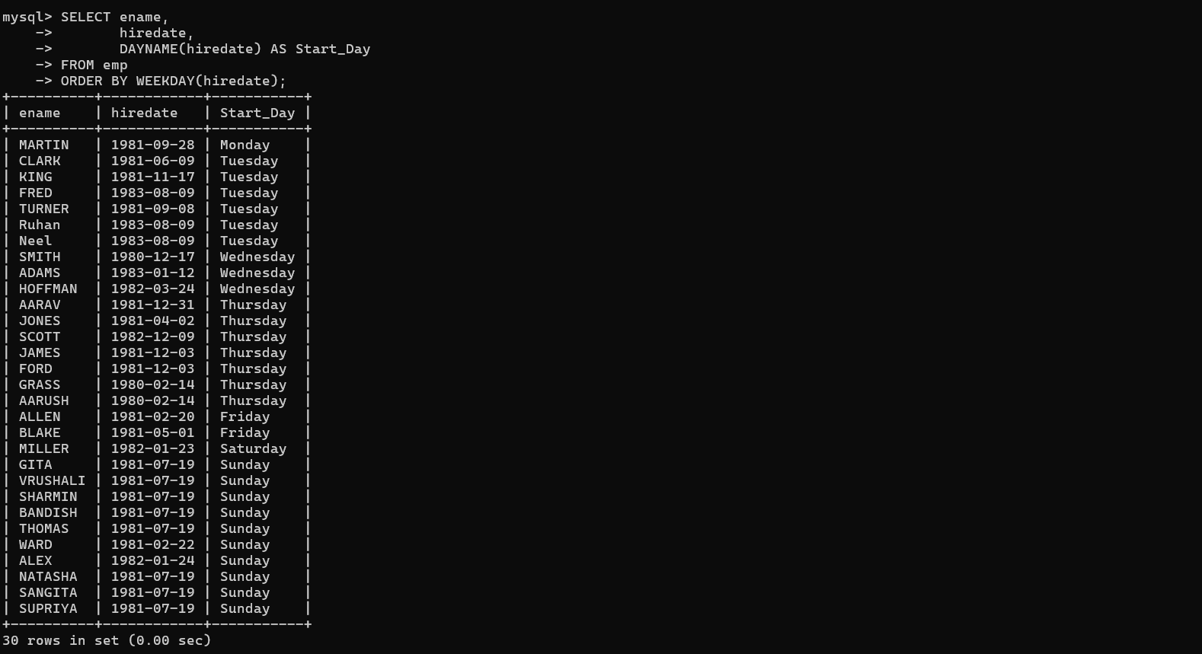

- Display details of orders received in the year 1986.

mysql> select * from orders where year(odate) = 1996;
//1986

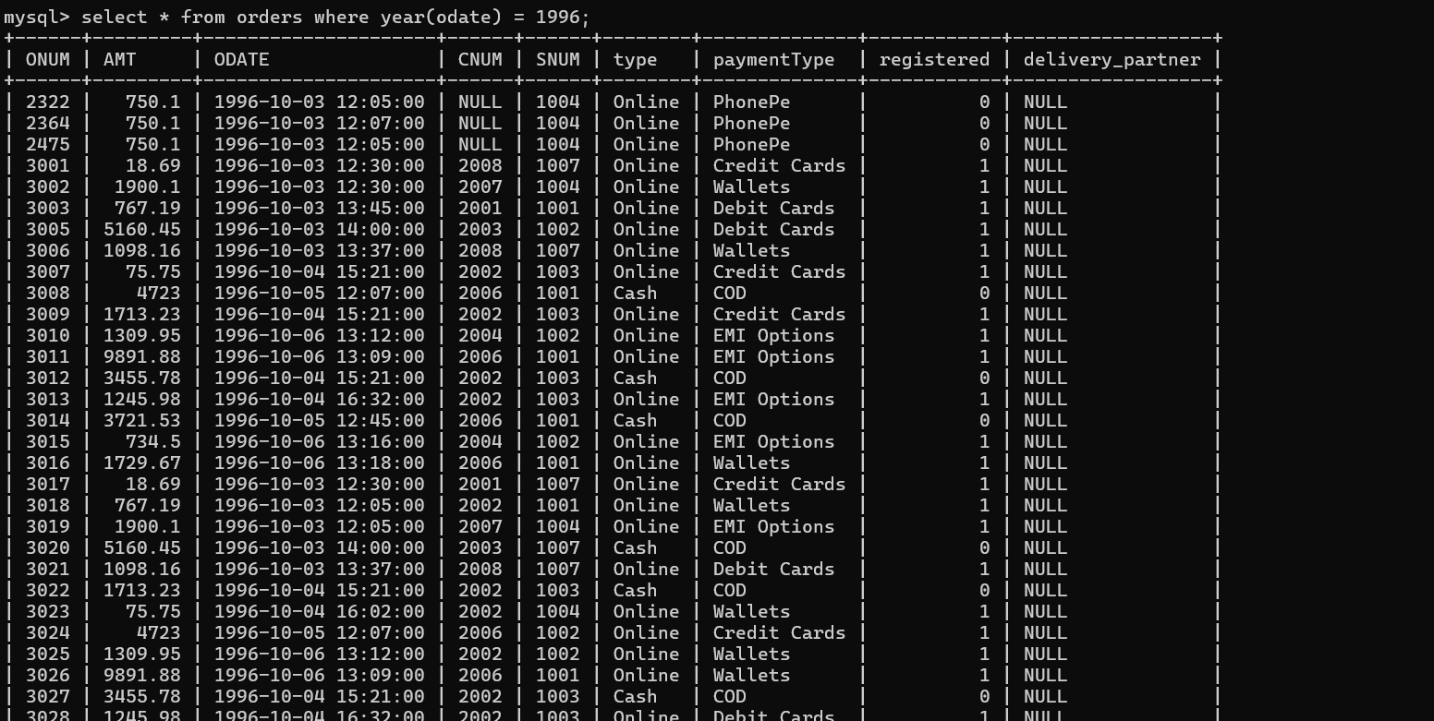

- Write a query to find out the DAY (for example, SUNDAY) of the current date.

mysql> SELECT DAYNAME(CURDATE()) AS Current_Day;
+-------------+
| Current_Day |
+-------------+
| Friday |
+-------------+
1 row in set (0.00 sec)

- Display the name and the date of joining of the employees who belong to department number 10. The date of joining should be formatted. For eg. if it is ‘10-JUN-97’ it should be displayed as Fifteenth JUNE, 1997. The name of the employee should be in upper case.
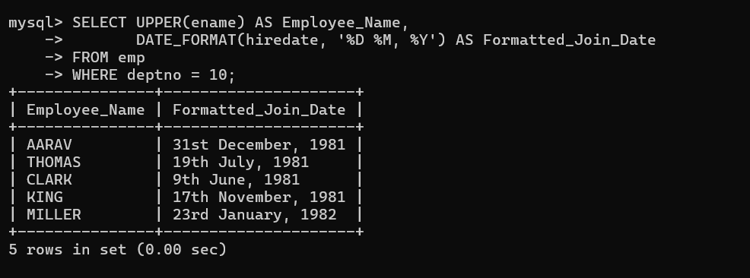

- Consider the Ord table. Find the difference between the Order Date and Ship Date in months as well as days. Label the columns appropriately.

SELECT
ORDID,
ORDERDATE,
SHIPDATE,
TIMESTAMPDIFF(MONTH, ORDERDATE, SHIPDATE) AS Diff_Months,
TIMESTAMPDIFF(DAY, ORDERDATE, SHIPDATE) AS Diff_Days
FROM ord;
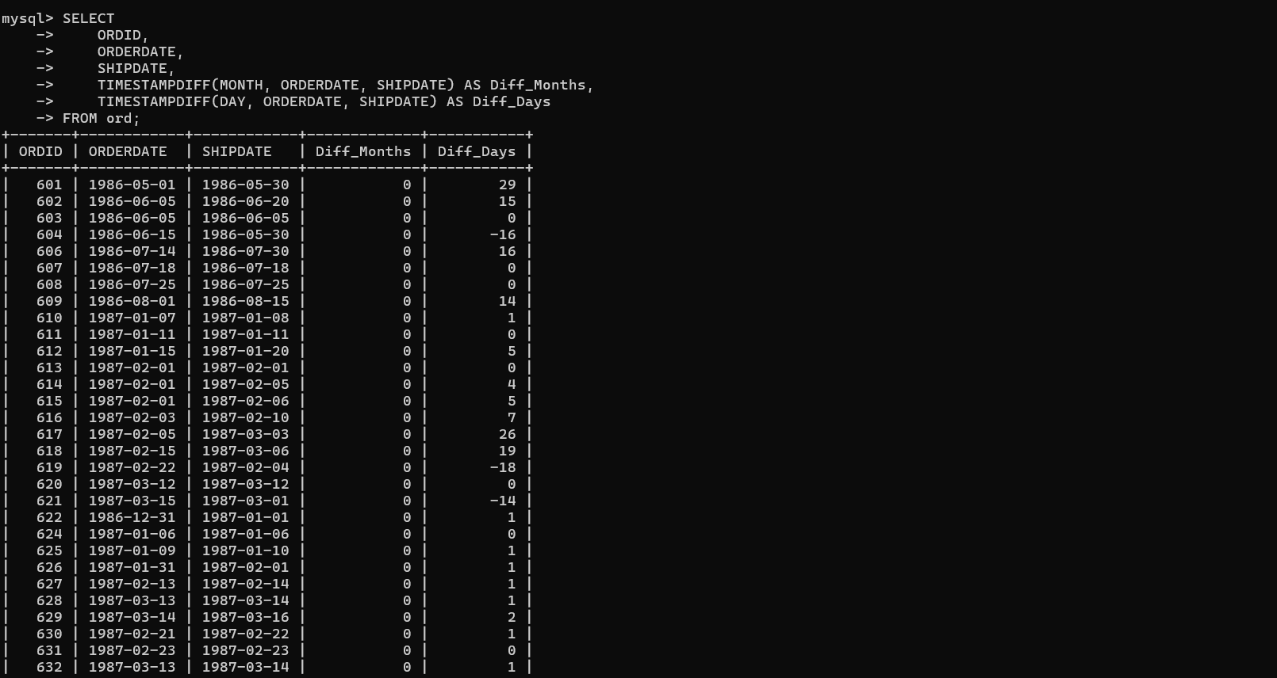

- List employee details who have joined in December.

SELECT
EMPNO,
ENAME,
JOB,
HIREDATE,
MONTHNAME(HIREDATE) AS JoinMonth
FROM emp
WHERE MONTH(HIREDATE) = 12;
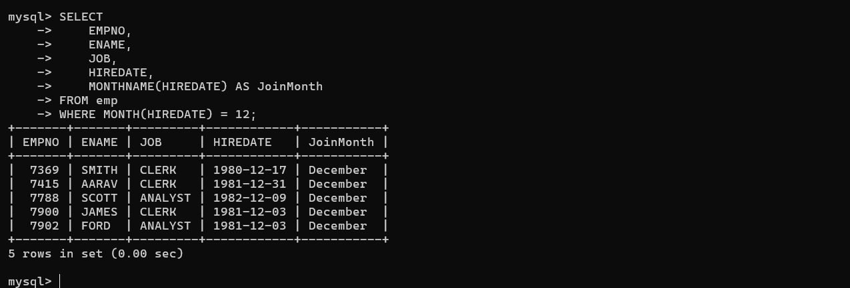

- Display day on which KING joined.

SELECT
ENAME,
HIREDATE,
DAYNAME(HIREDATE) AS Join_Day
FROM emp
WHERE ENAME = 'KING';

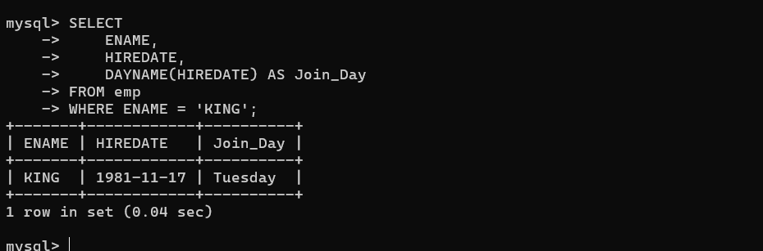

- Display month on which MARTIN joined.
SELECT
ENAME,
HIREDATE,
MONTHNAME(HIREDATE) AS Join_Month
FROM emp
WHERE ENAME = 'MARTIN';
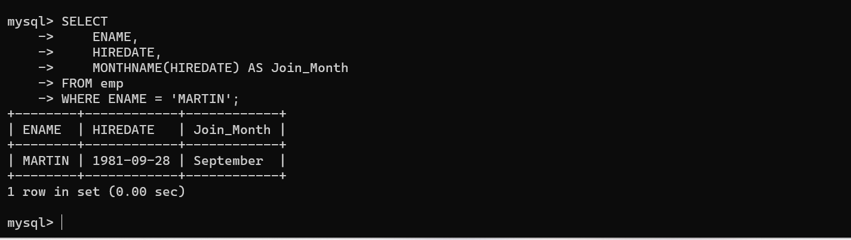
- Find number of days elapsed between today’s date and hiredate of ‘ADAMS’.
SELECT
ENAME,
HIREDATE,
DATEDIFF(CURDATE(), HIREDATE) AS Days_Elapsed
FROM emp
WHERE ENAME = 'ADAMS';

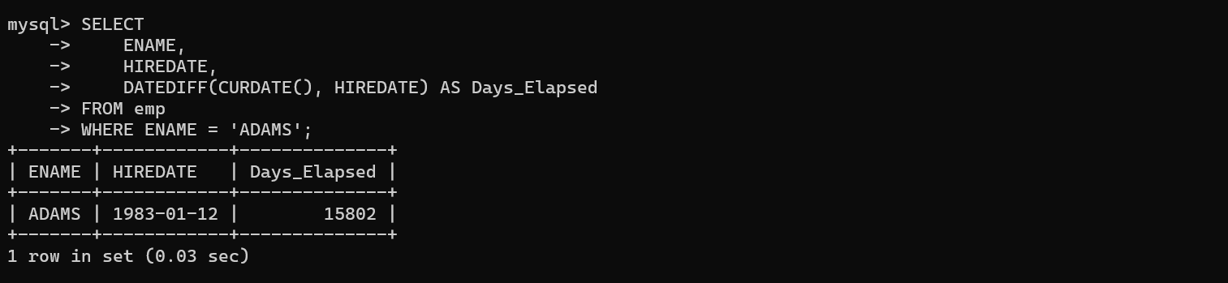
- Print the date, 15 days alter today’s date.
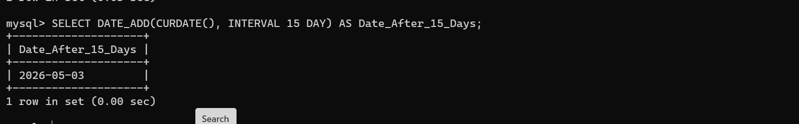
mysql > SELECT DATE_ADD(CURDATE(), INTERVAL 15 DAY) AS Date_After_15_Days;

- List all employee hired in the month of December.
SELECT
EMPNO,
ENAME,
JOB,
HIREDATE,
MONTHNAME(HIREDATE) AS Hire_Month
FROM emp
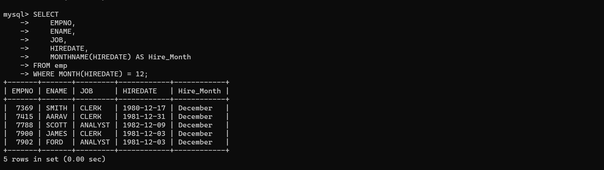
WHERE MONTH(HIREDATE) = 12;

- List all employee hired after 1980.
SELECT
EMPNO,
ENAME,
JOB,
HIREDATE,
YEAR(HIREDATE) AS Hire_Year
FROM emp WHERE YEAR(HIREDATE) > 1980;
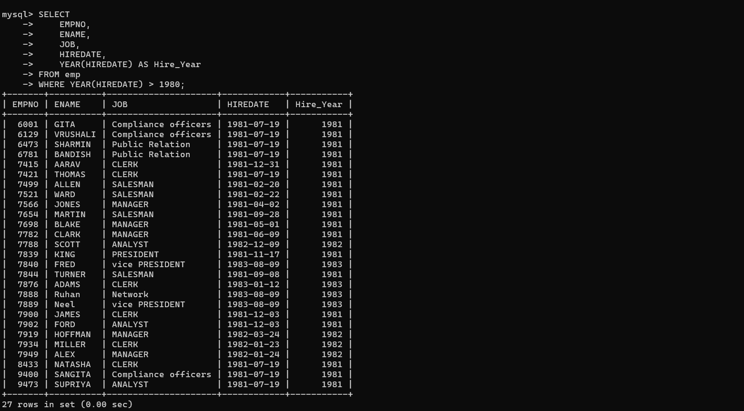

- Display names and jobs of employee in the format SMITH-CLERK.
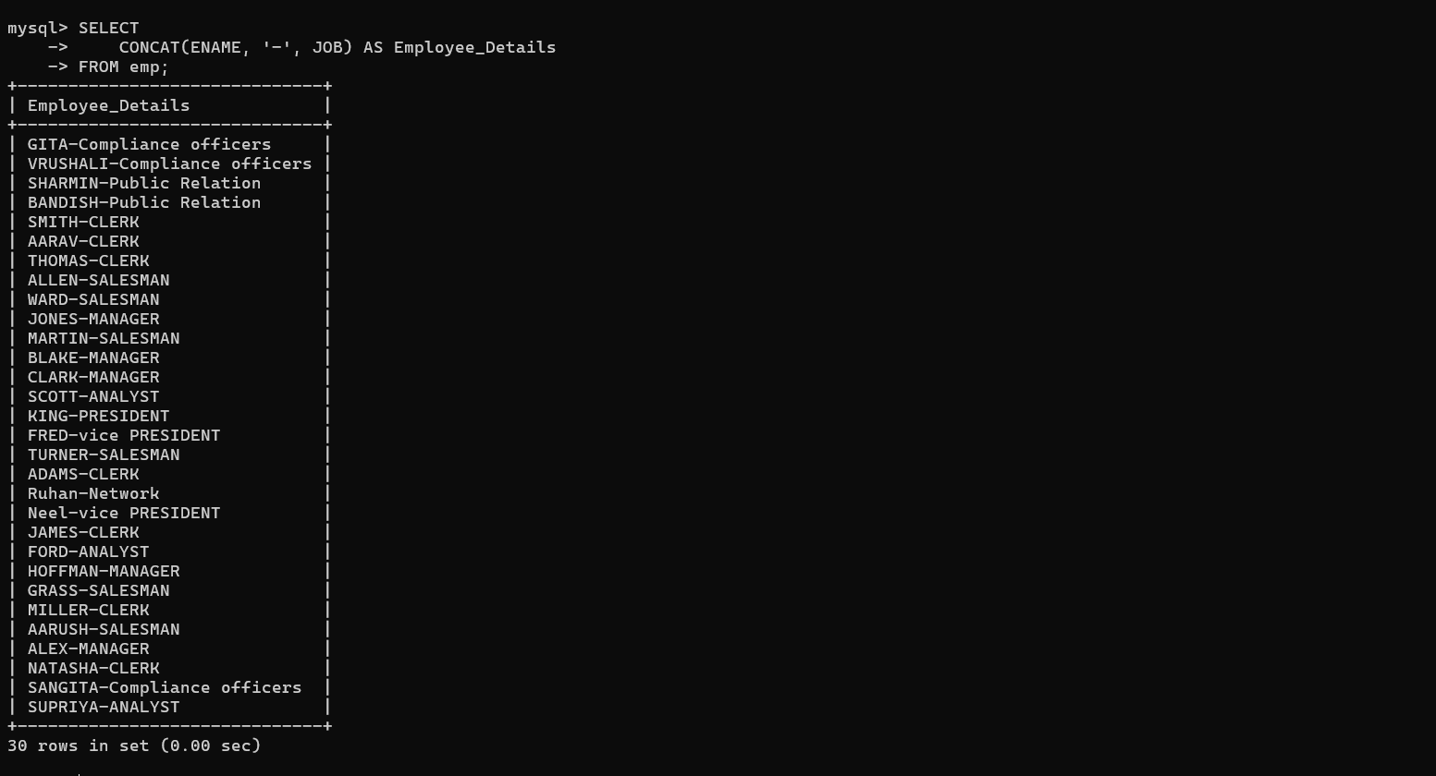
Mysql> SELECT CONCAT(ENAME, '-', JOB) AS Employee_Details FROM emp;

- Show the length of names in EMP table. Eliminate duplicate length. Do not show the names.
Mysql> SELECT DISTINCT LENGTH(ENAME) AS Name_Length FROM emp;
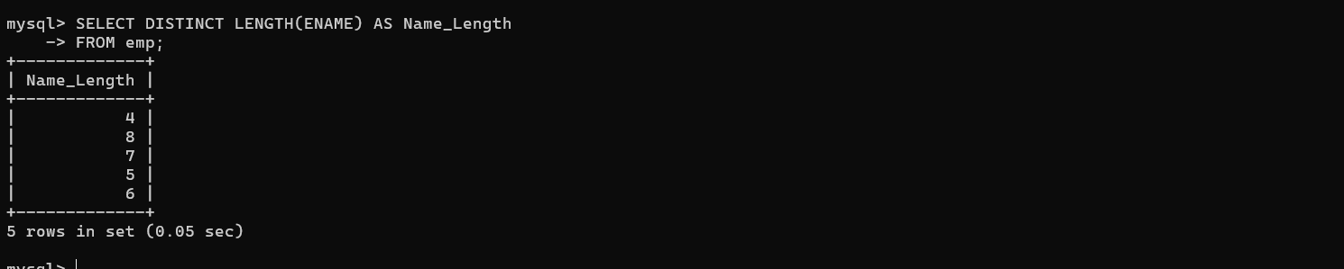
- List the names and hiredate of EMP in dept 20, display hiredate formatted as 12/03/1984.
SELECT
ENAME,
DATE_FORMAT(HIREDATE, '%d/%m/%Y') AS Formatted_HireDate
FROM emp
WHERE DEPTNO = 20;
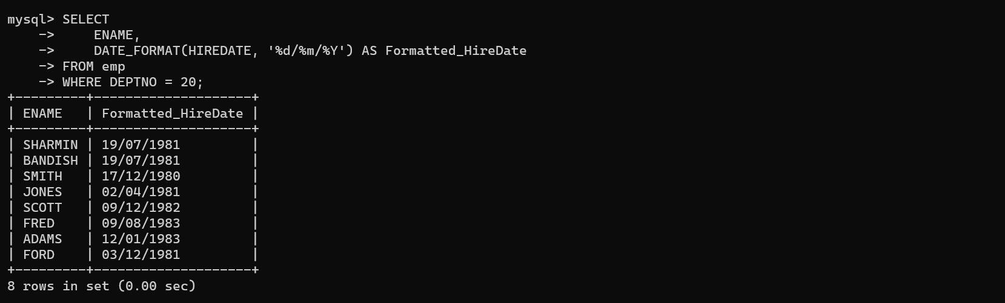
- Find the day of week on which SMITH joined.
SELECT
ENAME,
HIREDATE,
DAYNAME(HIREDATE) AS Join_Day
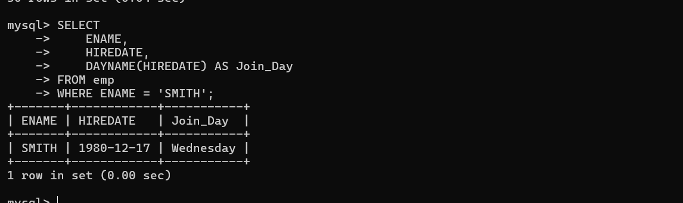
FROM emp WHERE ENAME = 'SMITH';
- Retrieve the ANALYST record with hiredate formatted as ‘The 3rd of Oct. 1984’.
SELECT
ENAME,
JOB,
CONCAT('The ', DATE_FORMAT(HIREDATE, '%D'), ' of ', DATE_FORMAT(HIREDATE, '%b. %Y')) AS Formatted_HireDate
FROM emp
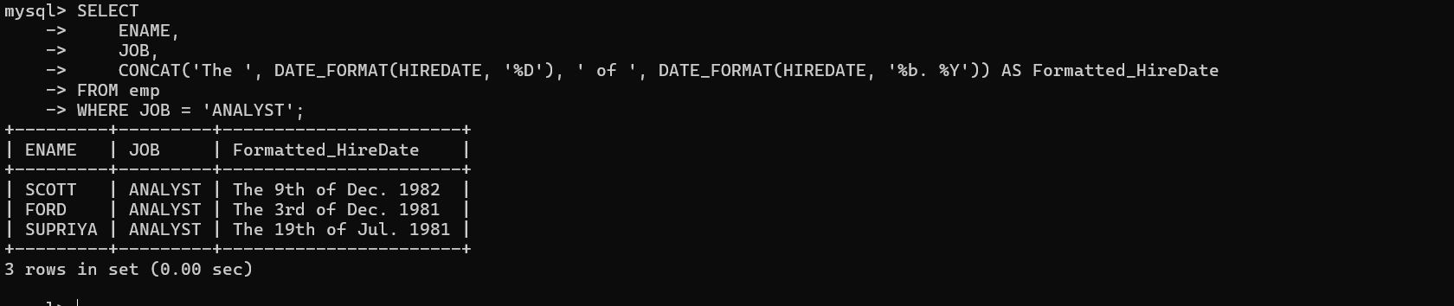
WHERE JOB = 'ANALYST';

- Calculate the total compensation expensive for each dept in 1 year. Assume that employees, who don't earn commission, receive non-monetary benefits than are worth Rs.1000 a month.
SELECT
DEPTNO,
SUM(
SAL * 12 +
IFNULL(COMM, 0) +
(CASE WHEN COMM IS NULL OR COMM = 0 THEN 12000 ELSE 0 END)
) AS Total_Compensation
FROM emp
GROUP BY DEPTNO;
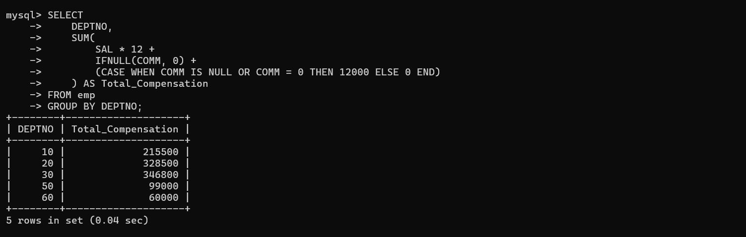
- Display the Names of the Managers as follows-
- If the employee code is 7788 the Manager is CLARK
- If the employee code is 7698 the Manager is BLAKE
- If the employee code is 7566 the Manager is JONES
- For all other Employees the Manager is KING

SELECT
EMPNO,
ENAME,
CASE
WHEN EMPNO = 7788 THEN 'CLARK'
WHEN EMPNO = 7698 THEN 'BLAKE'
WHEN EMPNO = 7566 THEN 'JONES'
ELSE 'KING'
END AS Manager
FROM emp;

